 | S2c/E Shape
73 | Draw in one plane of symmetry on this shape.  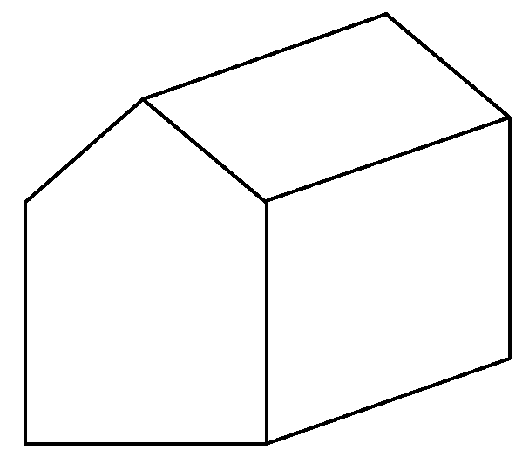 | 2
 | S2b/D
74 | Karl's and Eleanor's school is near a busy main road.  They decide to carry out a survey of the different types of vehicles that travel on the main road.  Design a suitable data sheet so that they can collect their data easily. | 3
 | S2d/D
75 | a The diagram shows a quadrilateral  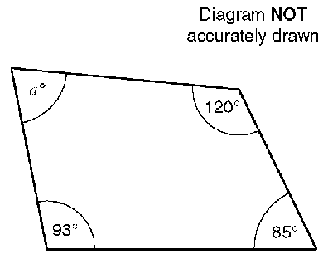  Work out the size of the angle marked aº.  b The diagram shows a regular hexagon.  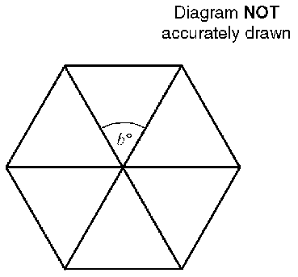  Work out the size of the angle marked bº.  c The diagram shows a regular octagon.  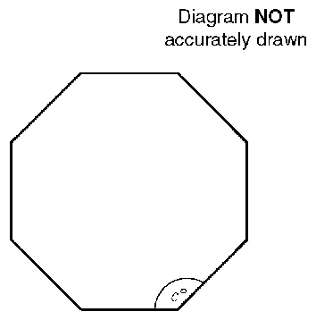  Work out the size of the angle marked cº. | 6
 | S2e/C
76 | Calculate the length of AB.  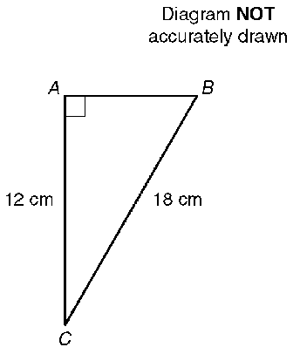  Give your answer correct to 1 decimal place. | 3
 | S2e/f/C
77 | The diagram is part of a map showing the positions of three Nigerian towns.  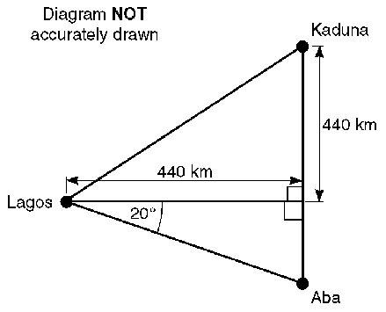  Kaduna is due North of Aba.  a Calculate the direct distance between Lagos and Kaduna.  Give your answer to the nearest kilometre.  b Calculate the distance between Kaduna and Aba.  Give your answer to the nearest kilometre. | 5
 | S2e/f/C
78 | Sidney places the foot of his ladder on horizontal ground and the top against a vertical wall.  The ladder is 16 feet long.  The foot of the ladder is 4 feet from the base of the wall.  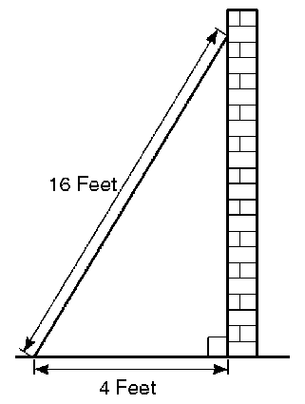  a Work out how high up the wall the ladder reaches.  Give your answer to 3 significant figures.  b Work out the angle the base of the ladder makes with the ground.  Give your answer to 3 significant figures. | 6
 | S2e/f/C/B
79 | Here is a side view of a swimming pool.  ABCD is a horizontal straight line. AH, BG, CF and DE are vertical lines.  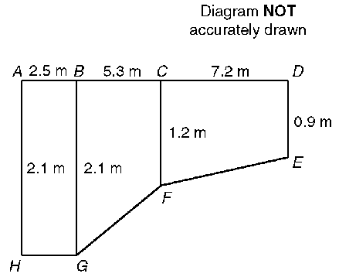  a Calculate the length of the line FG. Give your answer correct to 3 significant figures.  b Calculate the angle that the line GF makes with the horizontal. Give your answer correct to 1 decimal place. | 6
 | S2f/C
80 | In the diagram AB = 17.9 m,  BD = 8.2 m, angle CBD = 37º  and angle BDC = 90º.  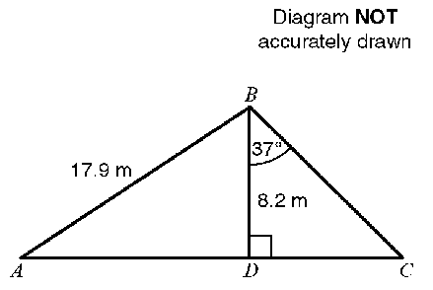  ADC is a straight line.  a Calculate the length of DC.  Give your answer, in metres, correct to 3 significant figures.  b Calculate the size of angle DAB. Give your answer correct to 1 decimal place. | 6
 | S2f/C
81 | The diagram shows a house and a garage on level ground.  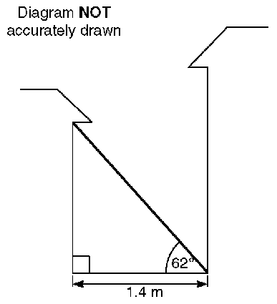  A ladder is placed with one end at the bottom of the house wall.  The top of the ladder touches the top of the garage wall.  The distance between the garage wall and the house is 1.4 m.  The angle the ladder makes with the ground is 62º.  a Calculate the height of the garage wall. Give your answer correct to 3 significant figures.  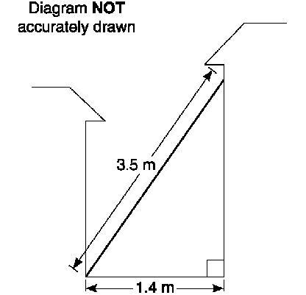  A ladder of length 3.5 m is then placed against the house wall.  The bottom of this ladder rests against the bottom of the garage wall.  b Calculate the angle that this ladder makes with the ground.  Give your answer correct to 1 decimal place. | 6
 | S2e/B
82 | Calculate the length of a diagonal of this rectangle.  Give your answer in centimetres correct to one decimal place.  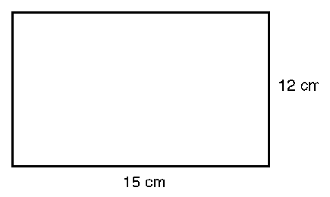 | 3
 | S3a/E
83 | San Fernando is on a bearing of 157º from Pasadena.  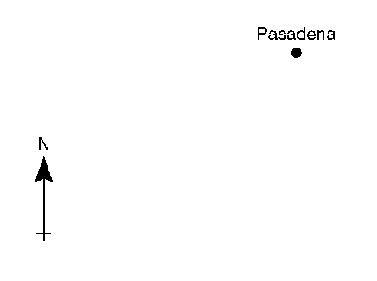  Draw this bearing accurately on the diagram above. | 2
 | S3c/E
84 | The shape shown can be used to tessellate the inside of the rectangle shown.  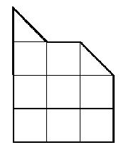  Show, on the grid below, how this shape tessellates.  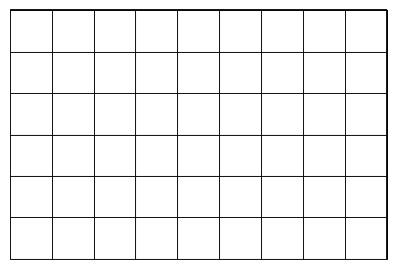 | 2
 | S3d/E
85 | Rashmi uses a map with a scale of 1 to 50 000.  She measures the distance between two points on the map.  The distance that Rashmi measures on the map is 8.2 cm.  Work out the actual distance between the two points  Give your answer in kilometres. | 3
 | S2b/D
86 | The scale drawing below shows the positions of an airport tower, T, and a radio mast, M.  1 cm on the diagram represents 20 km.  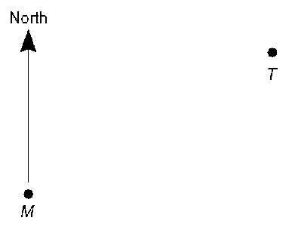  a i Measure, in centimetres, the distance TM.  ii Work out the distance in km of the airport tower from the radio mast.  b i Measure and write down the bearing of the airport tower from the radio mast.  ii Write down the bearing of the radio mast from the airport tower.  A plane is 80 km from the radio mast on a bearing of 220º.  c Plot the position of the plane, using a scale of 1 cm to 20 km on the scale diagram. | 8
 | S3d/C
87 | The Fast Foto company uses two letter F's as part of their logo.  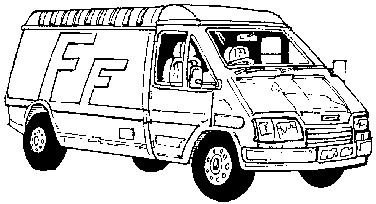  The letter F's are similar in shape.  The lengths of the large F and the lengths of the small F are in the ratio 3:2.  The height of the large F is 0.9m.  a Work out the height of the small F.  The width of the small F is 28 cm.  b Work out the width of the large F. | 4
 | S3d/C
88 | Seamus and Mick set off on a journey from a point A They travelled 30 km on a bearing of 060º to a point B. From B they travelled 48 km on a bearing of 210º to a point C.  a Using a scale of 1 cm to represent 4 km draw a scale drawing of their journey.  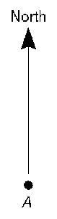  b i Work out how far C is from A.  ii Write down the bearing of A  from C. | 9
 | S3d/C
89 | Shape A is shown in the diagram.  Shape A is enlarged to obtain the shape B.  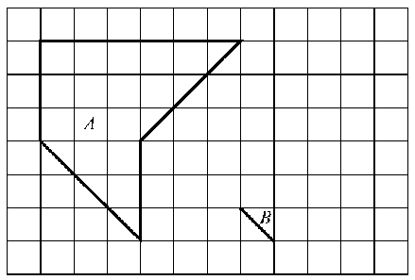  a Write down the scale factor of the enlargement.  b Complete the drawing of shape B on the diagram. | 3
 | S3e/C
90 | P and Q are two points marked on the grid.  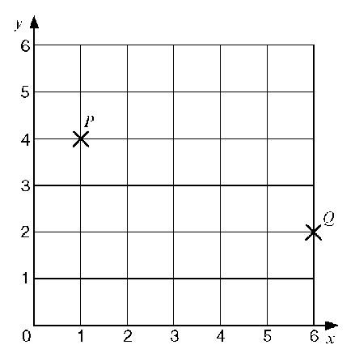  Construct accurately the locus of all points which are equidistant from P and Q. | 2
 | S3b/C/B
91 | a Reflect shape S in the line x = 0. Label the new shape T.  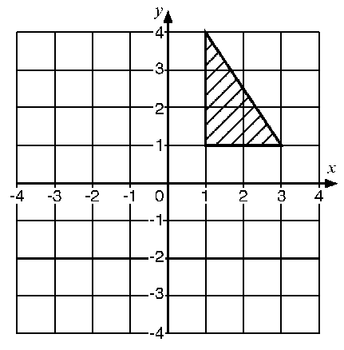  b Rotate the new shape T through an angle of 90º anticlockwise using (0, 0) as the centre of rotation. Label the new shape U.  c Describe fully the single transformation that will move shape U back onto shape S. | 6
 | S3d/B
92 | Triangle ABC is similar to triangle PQR.  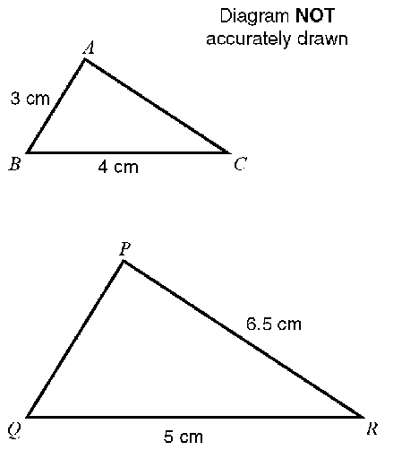  Angle ABC = angle PQR.  Angle ACB = angle PRQ.  Calculate the length of:  i PQ  ii AC | 5
 | S3d/B
93 | Here is a diagram of a company logo.  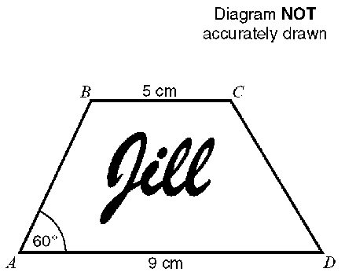  The diagram is enlarged so that the length BC becomes 7.5 cm.  a Work out the length of the enlarged side AD.  The enlarged side AB is 6 cm.  b Work out the length AB on the original diagram.  c What is the size of angle A in the enlarged diagram? | 5
 | S4d/E
94 | In this question you must write down the units of your answer.  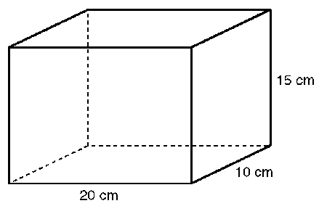  a Work out the area of the base of the solid shape.  b i Work out the volume of the solid shape.  ii Write this volume in litres | 7
 | S4d/D
95 | The diagram shows a circle of diameter 70 cm inside a square of side 70 cm.  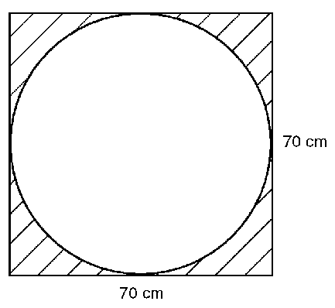  Work out the area of the shaded part of the diagram.  Give your answer correct to 3 significant figures. | 6
 | S4d/D
96 | Here is a side view of a swimming pool.  ABCD is a horizontal straight line.  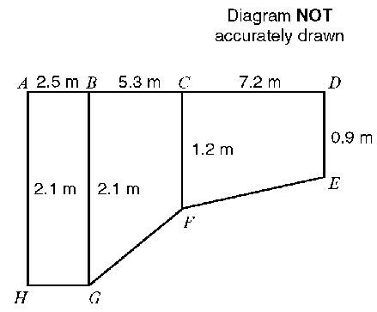  AH, BG, CF and DE are vertical lines.  a Write down the mathematical name for the quadrilateral BCFG.  b Work out the area of quadrilateral BCFG. | 5
 | S4d/D
97 | Mary has a circular dining table with a radius of 0.65 m.  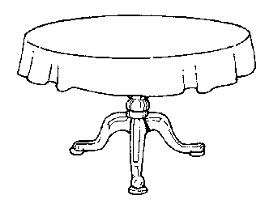  a Work out the area of the top of the table. Give your answer to 3 significant figures.  The perimeter of the circular tablecloth is 5m.  b Work out the diameter of the tablecloth. | 6
 | S4a/C
98 | There are 12 inches in 1 foot.  There are 3 feet in 1 yard.  There are 2.54 centimetres in 1 inch.  Express 1 metre in yards. Give your answer correct to 3 decimal places. | 3
 | S4a/C
99 | There are 2.54 centimetres in 1 inch.  There are 12 inches in 1 foot.  There are 3 feet in 1 yard.  i Calculate the number of yards in 10 metres.  ii Calculate the number of metres in 10 yards. | 4
 | S4a/C
100 | There are 14 pounds in a stone.  There are 2.2 pounds in a kilogram.  A man weighs 13 stone 6 pounds.  Work out his weight in kilograms.  Give your answer to the nearest kilogram. | 4
 | S4d/C
101 | The diagram shows a triangular prism.  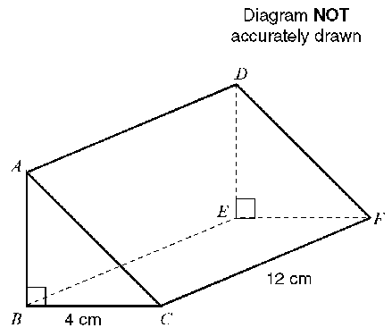  BC = 4 cm, CF = 12 cm and angle ABC = 90º.  The volume of the triangular prism is 84 cm³.  Work out the length of the side AB of the prism. | 3
 | S4d/C
102 | The shape below is the cross section of a prism 10 cm long.  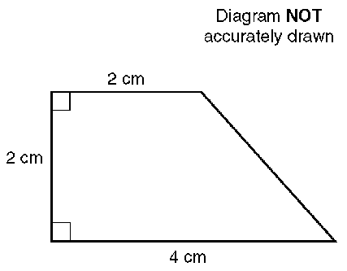  Calculate the volume of the prism. | 3
 | S4d/C
103 | The diagram shows a cylinder.  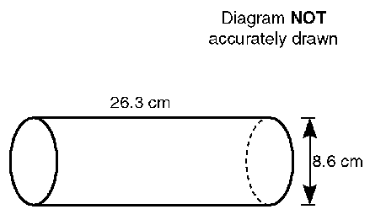  The height of the cylinder is 26.3 cm.  The diameter of the base of the cylinder is 8.6 cm.  Calculate the volume of the cylinder.  Give your answer correct to 3 significant figures. | 3
 | S4a/C/B
104 | There are 6 groats in a florin and 5 florins in 10 shillings.  Work out how many  i groats there are in 5 florins,  ii florins there are in 24 shillings,  iii groats there are in 8 shillings. | 6
 | S4d/B
105 | The expressions shown below can be used to calculate lengths, areas or volumes of various shapes.  The letters r and h represent lengths. π, 2, 3, 4, 5 and 10 are numbers which have no dimensions.  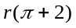 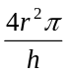 r(r + 4h) 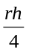 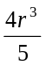  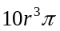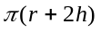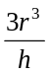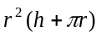  Draw a circle around each of the expressions which can be used to calculate an area. | 3
 | S4d/B
106 | The diagram represents a solid shape.  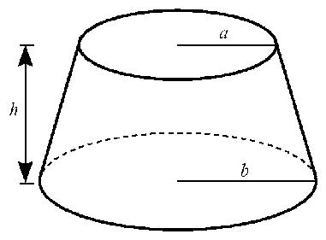  From the expressions below, choose the one that represents the volume of the solid shape.  π and are numbers which have no dimensions.  a, b and h are lengths.  π(b² - ab + a²), πh(b² + ab + a²), πh²(b² - a²),  π(a² + b²), πh²(b² - ab + a²).  Write down the correct expression. | 1
 | S3e/S4b/C
107 | The scale diagram shows the position of a radio mast, M.  1 cm on the diagram represents 20 km.  •  M  Signals from the radio mast can be received up to a distance of 100 km.  a Shade the region on the scale diagram in which signals from the radio mast can be received.  The distance of a helicopter from the radio mast is 70 km correct to the nearest kilometre.  b Write down  i the maximum distance the helicopter could be from the radio mast,  ii the minimum distance the helicopter could be from the radio mast. | 4

